PROJECT REPORT
1. INTRODUCTION
1.1. OVERVIEW
The project in the zoho books for keerthi sweets
stours involves the creation of financial statement,
which includes income statement balance sheet
and cash flow statement these statement are
essential to assess the financial health of the
company.
1.2 PURPOSE
By creating a financial statement I the zoho
books we can gain deep understanding of our
company’s financial standing and make strategic
adjustments to improve your performance and it
helps in identify the trends
2. PROBLEM DEFINITION&DESIGN THINKING
2.1 EMPHATHY MAP
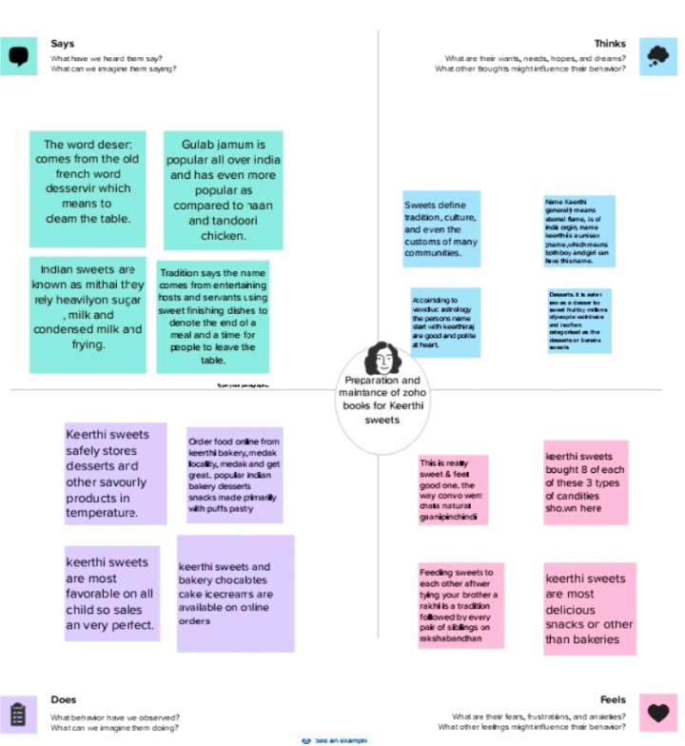
2.2 IDEATION & BRAINSTROMING MAP
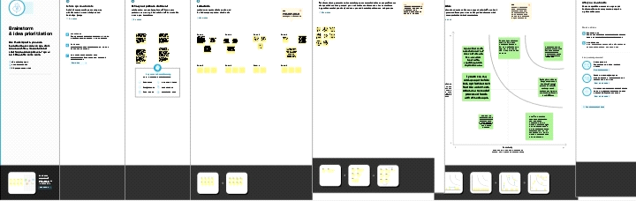
3.RESULT

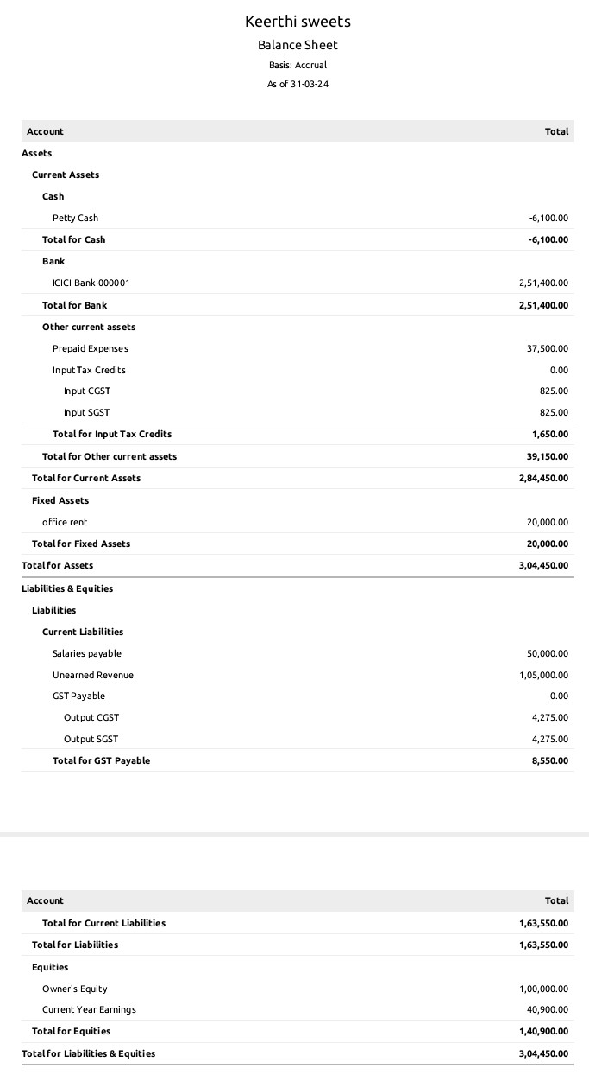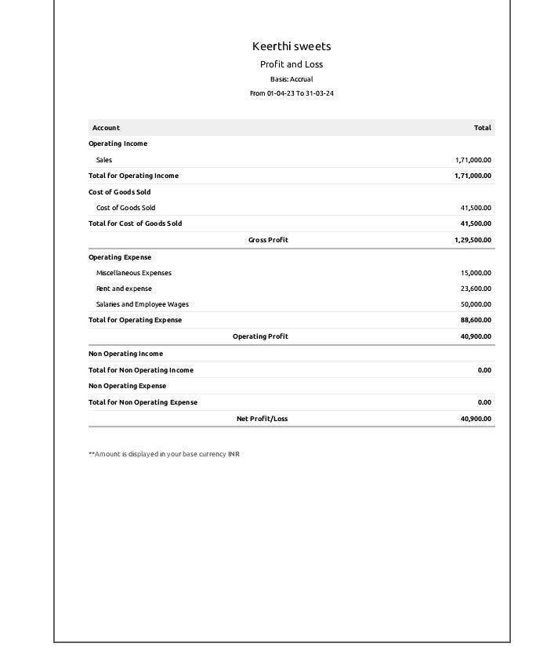
4.ADVANTAGE & DISADVANTAGE
1. User-friendly interface: Zoho Books has
a simple and intuitive interface that is easy
to use, even for those with little accounting
knowledge.
2. Affordable pricing: Zoho Books offers
affordable pricing plans that cater to small
business and freelancer
Disadvantages of Zoho Books:
1. Limited features: Zoho Books lacks some
features that other accounting software
offers, such as payroll, job costing, and
inventory tracking
2. Customer support: Some users have
reported difficulty in getting quick and
efficient customer support
5.APPLICATIONS
Zoho Books can also be applied in other
areas , including:
1. Inventory management: Zoho Books has
a basic inventory management
functionality that allows businesses to
track their inventory levels and monitor
stock movement.
2. CRM Integration: Zoho Books can be
integrated with Zoho CRM to improve sales
pipeline management.
6.CONCLUSION
To summarize the project done in Zoho
Books on financial statements, the
following can be presented:
All three financial statements generated
using Zoho Books will give an overview of
keerthi sweets' financial health, which
will help the management make informed
decisions to improve the company's
profitability and sustainability.
7.FUTURE SCOPE
As for enhancements that can be made for
future use, some suggestions are:
1. Customizable reporting: Zoho Books can
consider providing more options for the
customization of reports.
2.Improved mobile app: Zoho Books could
add more functionalities and features to its
mobile app to enhance on-the-go
accounting and make it more convenient
for users to access their financial
information.

